**Overview:**

In this prototype, a SNT kit with Arduino UNO board is used, but any board with one analog input could be used. This project requires some very simple soldering to attach 4 header pins with 500 0hms resistor to the perforated board.

**Measurement VOCs:**  Sensitive to hydrogen, ammonia, ethanol, hydrogen sulfide, toluene, cigarette smoke.

**Measurement Value**: ppm, Here we measure in Voltage

**Parts:** 1 x SNT kit with USB cable , 1 x TGS23062 H2S sensor( picture below),1 x Perforated board or Breadboard, Wires to solder and soldering station, conductive flux.

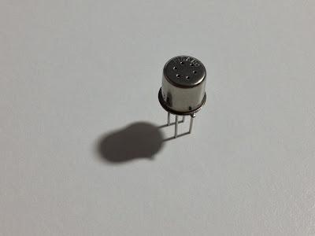

**Connection with SNT Kit:**

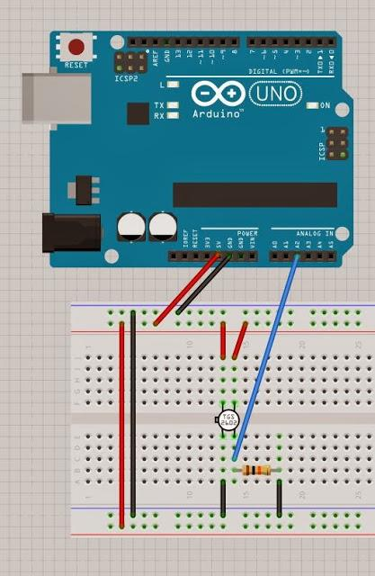

|  |  |
| --- | --- |
| TGS2602 sensor pins | SNT Kit |
| Pin1 - GND | - of A1 |
| Pin2 - In series 450 ohm or 500-ohm resistor, | The resistor is connected to the Arduino pin A1 |
| Pin3 - 5V | + Of A1 |
| Pin4 - 5V | + Of A2 |

Datasheet : [TGS2602 Datasheet](https://datasheet4u.com/datasheet-pdf-file/623050/Figaro/TGS2602/1)